
West Side Gymnastics School

Summer Schedule 2025
Classes start July 7th
Please sign up as soon possible.
Classes Fill Up Quick!
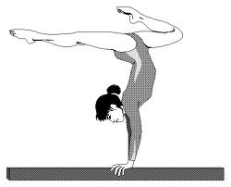
July 7th, 8th, 9th

July 14nd, 15th, 16th
July 21st, 22nd , 23rd
August 4th, 5th, 6th
August 11th, 12th, 13th
August 18th, 19th, 20^{thg}
